Contents
2.3A Overseas Support – Detailed Delivery Plan 2
A delivery model built around the location 2
Lead-time commitments and programme control 3
Global support footprint 4
Named overseas delivery routes 4
Dealer-network assurance and direct technical support 5
Access, security, customs and operational locations 5
Pulsefitness.ai/MODService – full overseas service capability 6
Central oversight, management information and continuity 8

2.3A Overseas Support – Detailed Delivery Plan
Tender Question: Demonstrate your ability to service, repair and maintain physical training equipment at overseas locations, including operational locations. Describe the infrastructure you will have in place to support this.
Scoring Focus: A detailed overseas-specific plan; anticipated lead-time breakdown; process map; evidence that lead times can be met; named third-party engineers/suppliers and controls.

Pulse Fitness will control every overseas Type C requirement from Congleton and select the safest and most effective delivery route: a vetted location-based engineer within the Global Pulse Fitness dealer network, direct deployment of a Pulse Fitness engineer, or a combined local and UK team. MODService will provide the operational fault-reporting, asset-evidence and service-visibility route for authorised MOD users in every territory.
6 | 33+ | 24 hours | 5 days
evidenced territories | global support routes | email acknowledgement | scheduled timeframe

A delivery model built around the location
Overseas requirements cannot be managed through a single fixed mobilisation model. A resident engineer may be the fastest and lowest-risk route in Gibraltar or Cyprus; Brunei may require direct deployment of a Pulse Fitness specialist; an operational area may need CONDO, sponsorship and consolidated parts; and a remote island requirement may depend on local continuity supported by international freight. Pulse Fitness validates the correct route before committing the programme.
Regardless of who attends, Congleton Head Office remains responsible for the quotation, purchase-order validation, engineer selection, technical escalation, parts, customer communication, service evidence, mandatory MSys.SIP status and final closure. The location changes; Pulse Fitness’s accountability does not.
This central structure is supported by the Global Pulse Fitness dealer network, direct manufacturer knowledge and a substantial UK stockholding. It allows local engineers to work with the same product information and escalation support as the directly employed UK team, while giving Team Leidos one commercial and operational owner.
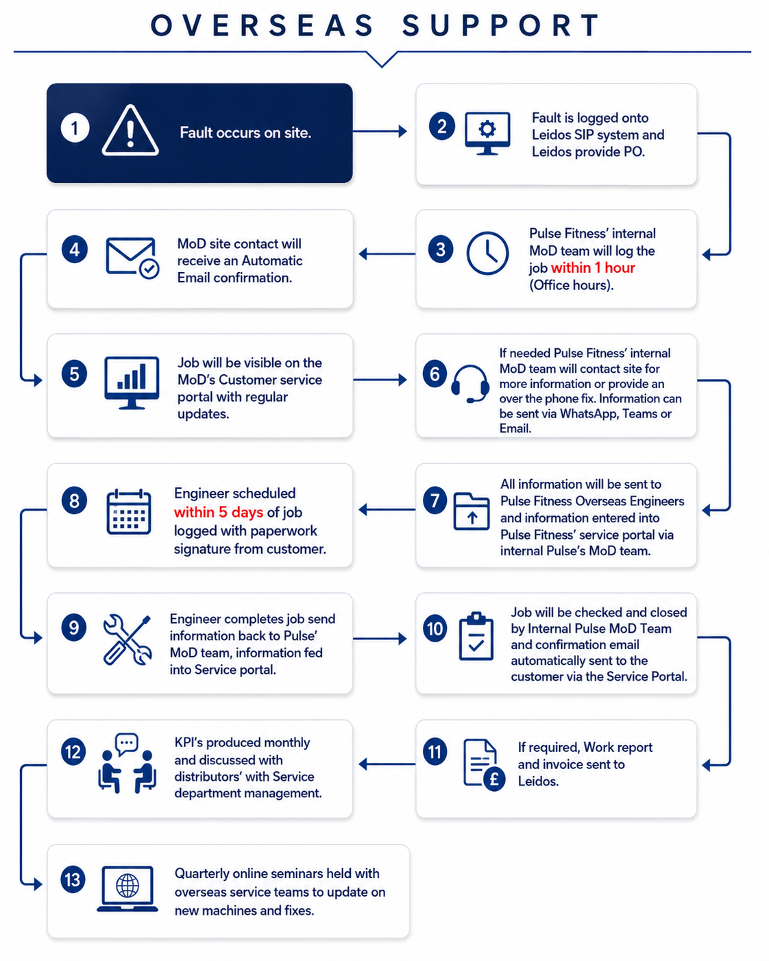
Figure 1 – Overseas support process from requirement to closure.
What the figure shows: The workflow follows the request and purchase order through job registration, acknowledgement, remote triage, route selection, quotation, access and parts planning, mobilisation, attendance, service evidence, SIP status and performance review.
Why it matters to the MOD: Overseas lead time is often affected by more than engineering availability. The process brings the engineer, permissions, travel, parts and evidence together as one plan, reducing the risk that an attendance is booked before the location is ready.

Lead-time commitments and programme control
Pulse Fitness will acknowledge the overseas request by email within 24 hours and provide a scheduled timeframe for the work within five working days. The programme will identify the named engineer, route, access dependencies, travel, security, parts, freight and evidence required at completion. The schedule will be realistic and itemised rather than promising an attendance before the practical route has been validated.
Remote and video triage will be used immediately where appropriate to confirm the exact asset, fault, safety status and likely components. If a trained location-based engineer is available, the visit will be programmed around local access and parts. If no suitable local engineer exists, Pulse Fitness will quote the complete direct-deployment route, including labour, travel, accommodation, permits or CONDO, parts, freight, customs and specialist tooling.
International stocked parts are normally dispatched through FedEx or DHL with a typical carrier period of three to five working days from dispatch. Transit remains subject to customs, import permission, operational restriction and site availability. Pulse Fitness will prepare the standard shipping and commercial documentation, while customer-only sponsorship, exemption or local import documentation will be identified within the programme.

Global support footprint
The map demonstrates the geographic reach of the Global Pulse Fitness dealer and deployment network. It is presented honestly as established or available support routes; it does not imply that a permanently contracted MOD engineer is resident in every marked country. Each route is confirmed against legal entity, competence, insurance, access, security and task suitability before the order is accepted.
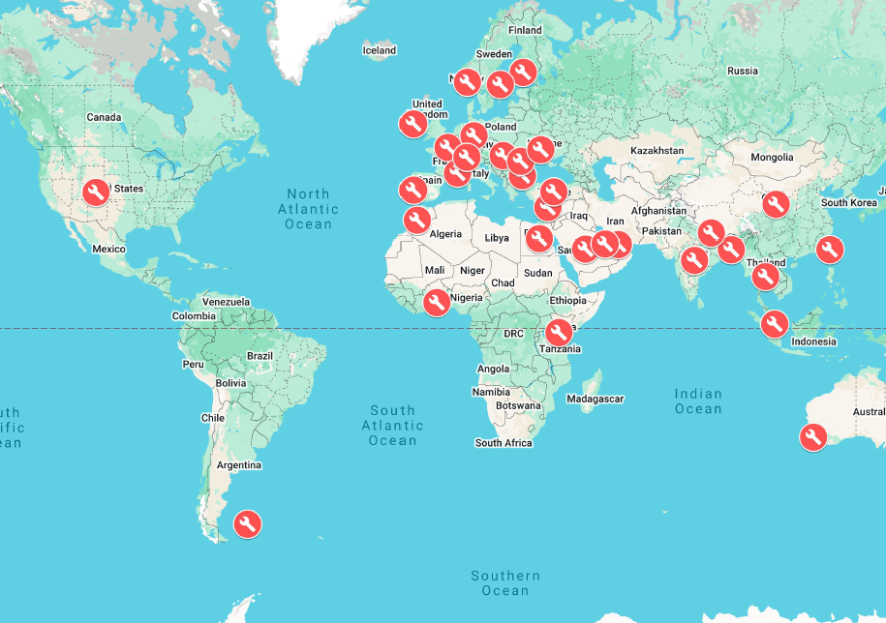
Figure 2 – Global Pulse Fitness dealer and deployment coverage.
What the figure shows: The map shows support routes across Europe, the Middle East, Africa, Asia, Australia, the Americas and the Falkland Islands.
Why it matters to the MOD: The footprint allows Pulse Fitness to combine local response with direct deployment. The Authority benefits from wider geographic reach without losing central commercial, technical and evidence control.

Named overseas delivery routes
The principal evidenced routes below demonstrate how Pulse Fitness distinguishes local support from direct UK deployment. The named schedule will be maintained through mobilisation and updated if a dealer or engineer changes, so that competence, insurance and support remain current.
Territory | Named engineer(s) | Delivery route | Primary role
Cyprus | Petros Aristidou | Local dealer-network engineer | In-country planned service and mixed-brand repair
Falkland Islands | Phil Barker | Local support engineer | Locally delivered servicing and reactive repair
Gibraltar | Sean Coakley/Jimmy Connors | Resident/local dealer-network engineer | Planned service and reactive mixed-brand repair
Kenya | John Maino | Local dealer-network engineer | BATUK planned service and mixed-brand repair
Germany | Frank Ehlers | Dealer-network engineer | Regional German support under Pulse Fitness control
Brunei | Jim Harper and Marcus Turner | Direct Pulse Fitness deployment | Planned deployment, specialist repair and assurance
Other specialist/high-risk locations | Named UK engineer selected to task | Direct or combined deployment | Complex, high-volume, mobilisation or assurance activity

Dealer-network assurance and direct technical support
Each organisation within the Global Pulse Fitness dealer network is carefully vetted and must demonstrate at least five years’ experience supplying, servicing or maintaining commercial fitness equipment. Appointment considers technical capability, capacity, insurance, local reputation, customer standards and the ability to work within Pulse Fitness reporting and escalation controls.
Dealer engineers supporting Pulse equipment attend in-house training at Pulse Fitness Head Office in Congleton. Training covers cardiovascular and strength products, planned maintenance, diagnostics, parts, warranty, reporting and escalation. Engineers are used only within demonstrated competence; specialist or unfamiliar work is supported by, or transferred to, a directly employed Pulse Fitness engineer.
Overseas engineers remain connected to Head Office by telephone, approved business WhatsApp and email. This live route gives them access to service, design, product, technical and stores specialists while they are on site. Product updates, recurring-fault information and evidence expectations are reinforced through regular technical communication and quarterly online seminars.

Access, security, customs and operational locations
Before committing a date, Pulse Fitness confirms the receiving contact, access window, escorts, PPE, working area, vessel or operational restrictions and any local sponsorship. Where work will take place in an operational area, Pulse Fitness will obtain the required CONDO documentation and discuss sponsorship with Team Leidos. Flights, accommodation, local transport, permits, tools and parts are then brought together in the same mobilisation plan.
Overseas MOD-owned machines will normally remain in-country. Any cross-border repair or storage movement is reviewed through the completed ECC Services and export-control process before dispatch. This prevents a repair decision from creating an avoidable customs, title or re-import risk.
TYPE C QUOTATION: Where a location-based engineer is not available, the itemised quotation will identify labour and travel time, flights or ferry, accommodation, subsistence, local transport, visas/permits or CONDO, parts, freight, customs/brokerage, duties or taxes where applicable and specialist tools or access requirements.

Pulsefitness.ai/MODService – full overseas service capability
MODService is not limited to UK delivery. It will be provided as the operational portal through which authorised MOD personnel at overseas sites can report faults, identify the exact asset, upload evidence and follow service activity. The same platform supports a local dealer engineer, a directly deployed UK engineer or a combined team, giving Pulse Fitness and the MOD one consistent record wherever the equipment is located.
This is particularly important overseas because service activity can cross time zones, languages, carriers and multiple organisations. MODService keeps the asset, fault, photographs, communication, parts, engineer evidence and lifecycle information together. Sicon continues to control Pulse Fitness’s internal scheduling, costs, parts and closure, while MSys.SIP records the mandatory purchase-order and completion or delay status.
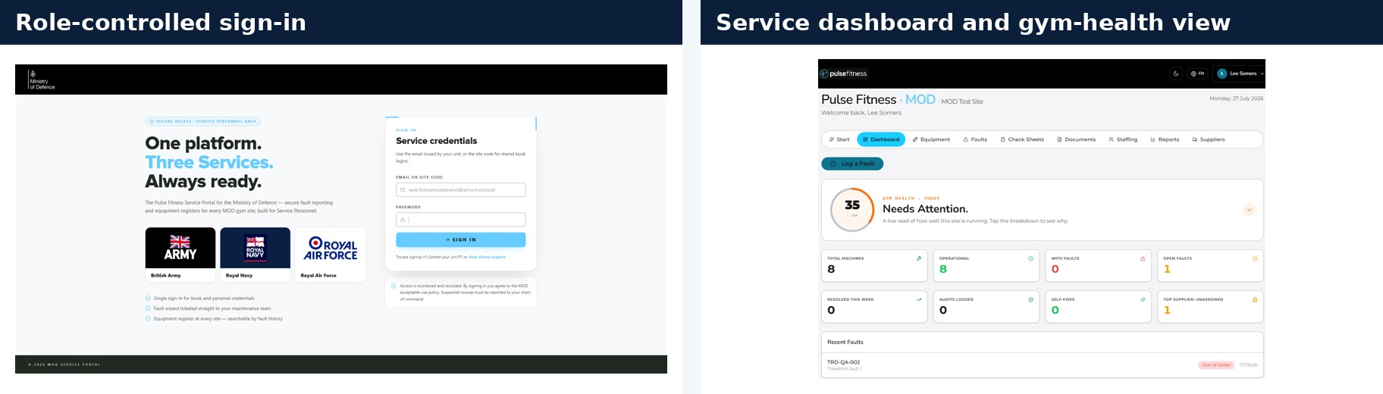
Figure 3 – Overseas MODService sign-in and central dashboard.
What the figure shows: The screens show role-controlled access and a central view of asset condition, open faults, recent activity and issues needing attention.
Why it matters to the MOD: The portal gives overseas sites a direct and consistent reporting route while Congleton retains live visibility. It reduces dependence on email chains and local spreadsheets, especially when support is being delivered through different routes.
The asset register carries the manufacturer, model, serial number, warranty, supplier, documents, QR identity, service history and current fault status. Site personnel can scan the machine, select the exact asset, describe the fault, upload photographs and record the steps already tried. This information can be reviewed before a local visit or before an engineer travels internationally.
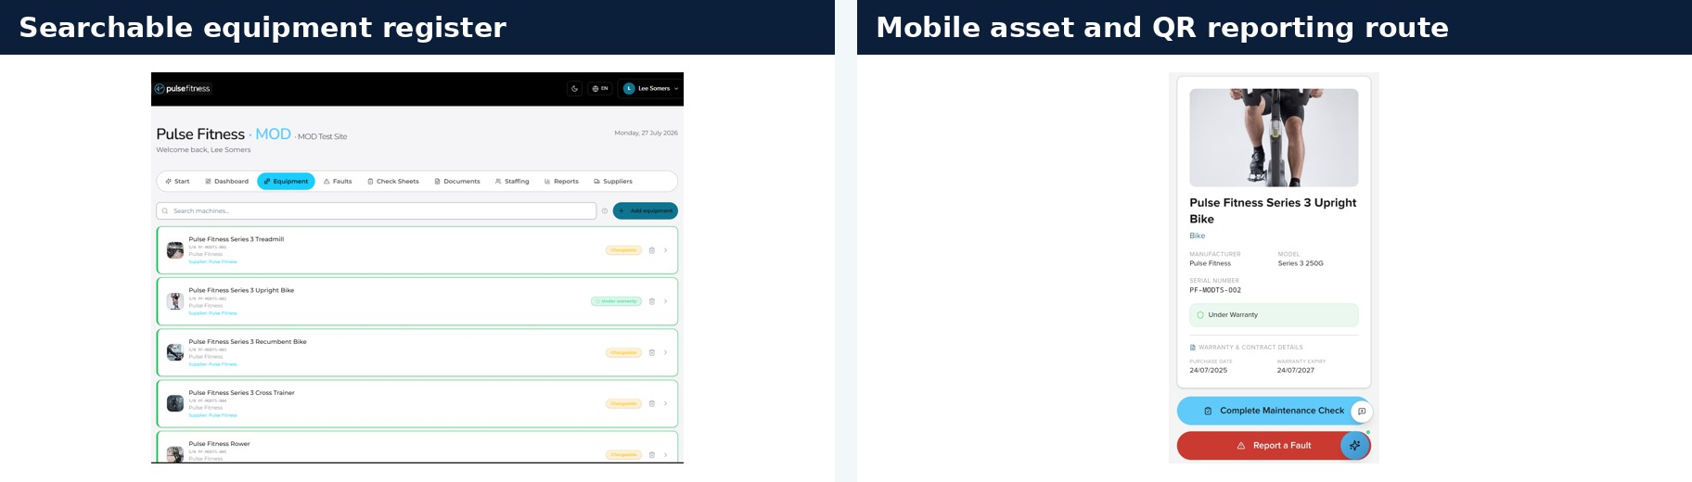
Figure 4 – Overseas asset register and QR reporting route.
What the figure shows: The searchable register provides one equipment record across the estate, while the mobile interface allows reporting directly from the machine.
Why it matters to the MOD: Accurate asset identity reduces wrong-part and unnecessary-travel risk. It also gives the engineer a clearer diagnosis and parts plan before mobilisation.
The job record retains the site, asset, serial, evidence, history, warranty, supplier reference, communication and current status. Parts dependencies and recovery actions remain visible until Pulse Fitness approves closure. Risk assessment support records probability, severity, residual risk and the assessor’s judgement, providing a structured route where local environmental or access conditions affect the work.
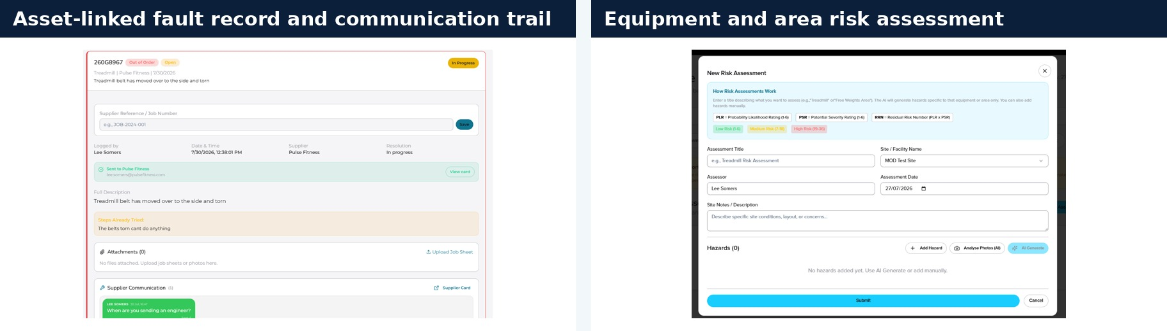
Figure 5 – Overseas job preparation, supplier communication and risk assessment.
What the figure shows: The screens combine the asset-linked service record with the equipment or area risk assessment and assessor control.
Why it matters to the MOD: The information allows a local or deployed engineer to work from the same prepared job pack and gives Pulse Fitness an auditable trail of the decisions behind attendance, isolation, parts and closure.
Lifecycle, condition and BER reporting turns overseas service information into a decision tool. Repeat faults, repair spend, downtime, safety events and asset condition can be reviewed by territory or across the wider estate. The Activity Safety Events Register links equipment risks and near misses to the exact machine, while personal incidents follow a separate factual pathway.
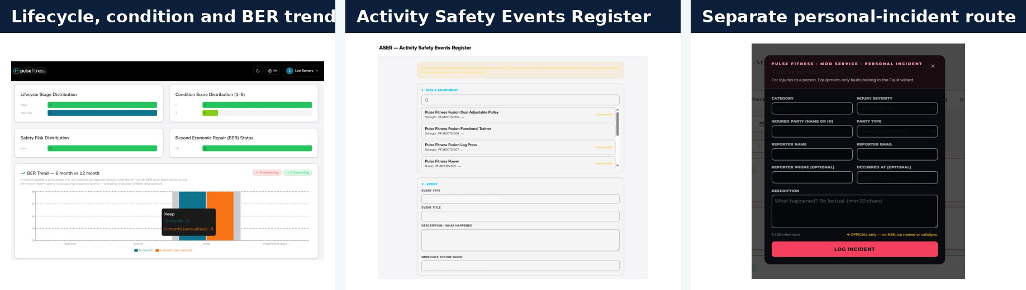
Figure 6 – Overseas lifecycle, BER and safety reporting.
What the figure shows: The figure shows condition and BER trend information, asset-linked safety events and the separate personal-incident route.
Why it matters to the MOD: Remote locations benefit from a central evidence base for repair, refurbishment and replacement. Decision-makers do not have to wait for paper reports to be manually collated after a deployment.

Central oversight, management information and continuity
MODService gives the site and authorised managers a view of the operational record, but Pulse Fitness remains responsible for the service. Congleton monitors response risk, access, travel, parts, open follow-on, report quality and final closure. Monthly management information can show territory demand, fault types, attendance, planned service, parts dependency, repeat issues and lifecycle trends.
Where the selected route becomes unavailable, Pulse Fitness can reassess the requirement and move between local, direct and combined delivery. A local engineer may be supported by a UK specialist; a direct deployment may be consolidated with other work; or parts may be sent in advance to reduce the duration of the visit. The programme and quotation are updated transparently before the revised route is committed.
OVERSEAS ASSURANCE: Pulse Fitness combines local knowledge, direct manufacturer support, vetted engineers, realistic mobilisation planning, tracked international logistics and full MODService visibility. Every route remains under one central service, parts, quality and evidence structure.

This plan provides Team Leidos and the MOD with genuine global reach without sacrificing accountability. The Authority receives the most appropriate engineer for the territory, a practical schedule that recognises access and logistics and the same asset-led visibility and evidence standard available in the UK.

North America (Canada) coverage
Pulse Fitness is currently expanding operations into North America and is establishing warehouse facilities in the United States and Canada from which Pulse Fitness engineers will work. Canadian attendance is therefore delivered by directly employed Pulse Fitness engineers operating from the North American base, quoted under the Type C mechanism on the same basis as other overseas deployments.
Overseas obligations and performance (Statement of Requirement 11.4)
The Schedule of Requirements sets no attendance lead-time for the overseas line; the contracted obligations are acknowledgement of the request by email within 48 hours and a scheduled timeframe for the work provided within five working days.
- Acknowledgement within 48 hours: 100% achieved (Pulse Fitness routinely acknowledges within 24 hours, improving on the 48-hour requirement).
- Scheduled timeframe within five working days: 100% achieved.
- Type C: 18 itemised quotations issued (labour, travel, accommodation, subsistence, local transport, freight and parts), of which 17 were accepted and delivered.
International parts are shipped via FedEx / DHL, typically 3–10 working days subject to customs, destination, import permissions, site access and operational restrictions. Where military transport is available and economical, Pulse Fitness is willing to use it subject to Authority agreement.
Service Portal (MODService) — overseas
The Pulse Fitness Service Portal (MODService) is a single global system used identically for UK and overseas sites. The screens supporting this response are filtered to an overseas site to show the overseas asset register, job records, risk assessments and lifecycle reporting.
[EDIT NOTE — Replace Figures 3–6 (currently UK screens) with MODService screens filtered to a genuine overseas site. Reissue Figure 1: split step 8 into (a) email acknowledgement within 48h / Pulse 24h and (b) scheduled timeframe within five working days; correct step 12 to 'Monthly MI to Team Leidos by the fifth day'. Use MSys.SIP on first mention.]

